Chapter 16, Solution 69.

Find I₁(s) and I₂(s) in the circuit of Fig. 16.92.

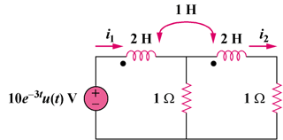

Figure 16.92
For Prob. 16.69.

Solution

Find I₁(s) and I₂(s) in the following circuit.

2 H

1 Ω

(10e^{–3t})u(t) V
+

i₁

2 H

1 Ω

i₂

H

Solution

Step 1. We note that the initial conditions in this case are equal to zero. Next, we need to convert the circuit into the s-domain and use the model for mutually coupled circuits. Then we can write the mesh equations and solve for I₁ and I₂.

1 Ω

I₂

1 Ω

10/(s+3)
+

I₁

2s

sI₂
+ −

2s

sI₁
+ −

Step 2. –[10/(s+3)] + 2sI₁ + sI₂ + 1(I₁–I₂) = 0 and
1(I₂–I₁) + 2sI₂ + sI₁ + 1I₂ = 0. Simplifying we get,

(2s+1)I₁ + (s–1)I₂ = 10/(s+3) and (s–1)I₁ + (2s+1)I₂ = 0.

We can solve this directly using substitution or use matrices. Let us use matrices.
The matrix inverse

Therefore,

I₁ = 6.667(s+0.5)/[s(s+2)(s+3)] and
I₂ = –3.333(s–1)/[s(s+2)(s+3)]

6.667(s+0.5)/[s(s+2)(s+3)], –3.333(s–1)/[s(s+2)(s+3)]

